**Assignment -1**

Python Programming

| Assignment Date | 08 September 2022 |
| --- | --- |
| Student Name | Ms. Ishwarya G K |
| Student Roll Number | 910619104029 |
| Maximum Marks |  |

## 1. Split this string

s = "Hi there Sam!"

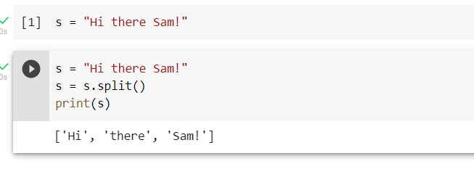

## 2. Use .format() to print the following string.

### Output should be: The diameter of Earth is 12742 kilometers.

planet = "Earth"

diameter = 12742

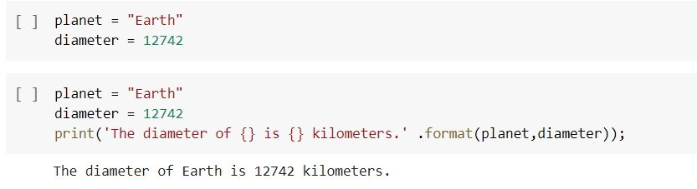

## 3. In this nest dictionary grab the word "hello"

d={'k1':[1,2,3,{'tricky':['oh','man','inception',{'target':[1,2,3,'hello']}]}]}

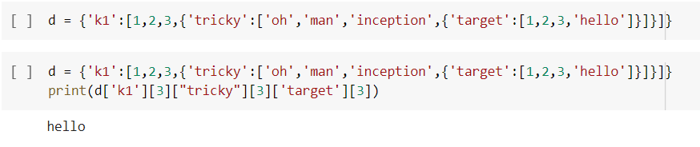

# 4. Numpy

## 4.1 Create an array of 10 zeros?

## 4.2 Create an array of 10 fives?

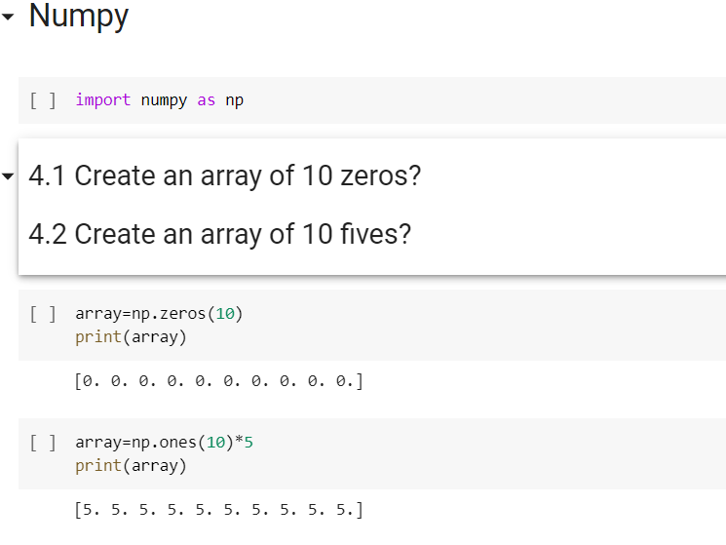

## 5. Create an array of all the even integers from 20 to 35

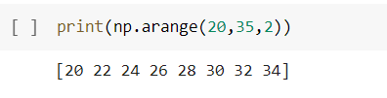

## 6. Create a 3x3 matrix with values ranging from 0 to 8

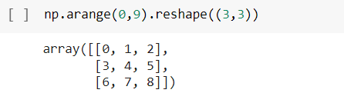

## 7. Concatinate a and b,a = np.array([1, 2, 3]), b = np.array([4, 5, 6])

## 

## 8. Pandas Create a dataframe with 3 rows and 2 columns

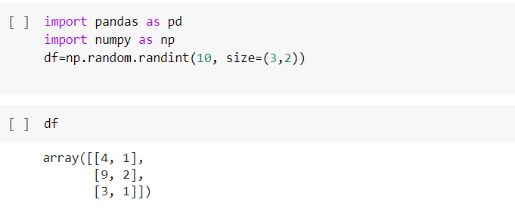

## 9. Generate the series of dates from 1st Jan, 2023 to 10th Feb, 2023

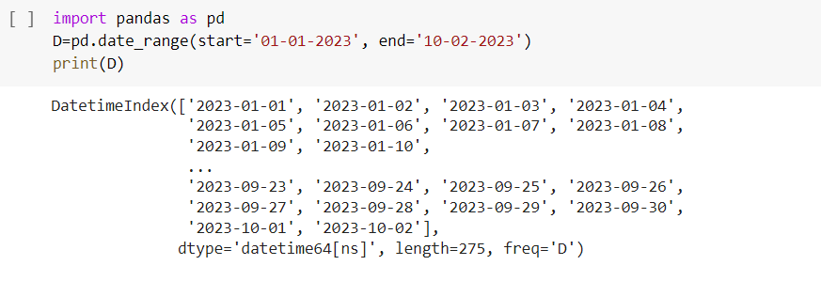

## 10. Create 2D list to DataFrame

lists = [[1, 'aaa', 22], [2, 'bbb', 25], [3, 'ccc', 24]]

